Assignment No. 1
Process Model Selection
University Timetable Optimization and Management System
Software Engineering Subject

Project: | University Timetable Optimization and Management System
Prepared For: | Course Instructor / Examiner
Prepared By: | Student Name / Registration No.
Submission Date: | ________________

Department of Computer Science / Software Engineering
University Assignment Report

1. Project Overview
The proposed system is a web-based University Timetable Optimization and Management System for preparing, reviewing, repairing, and publishing weekly timetables for courses, teachers, rooms, and student groups. The first release focuses on timetable administration for one department or faculty rather than on fully personalized student-by-student scheduling.
The project is not a simple record-management website. It must maintain academic structure, room and teacher data, constraints and preferences, draft timetable generation, clash review, controlled change handling, and final publication. Because many rules become clearer only after draft schedules are inspected, the process model must support staged development and early validation.
2. Process Model Selection Criteria
The following criteria were used to choose the most suitable lifecycle model for the project. They are derived from the characteristics of a timetable optimization system rather than from generic project-management templates.
- Requirement volatility: policy weights, exceptions, and timetable quality expectations may change after stakeholders see draft outputs.
- Visual validation need: forms, rule-configuration screens, timetable grids, and conflict reports must be reviewed early.
- Technical uncertainty: schedule generation, repair after changes, and controlled re-optimization introduce design risk.
- Modular architecture: the system can be built in separable slices such as master data, rule configuration, generation, review, and publication.
- Documentation requirement: coursework still expects formal written deliverables and traceable design decisions.
- Semester-scale feasibility: the selected lifecycle should be strong enough for the project, but not so heavy that the management overhead becomes excessive.
3. Candidate Models Considered
Four approaches were considered as realistic alternatives for the report: Waterfall, Incremental, Spiral, and Agile/XP practices. Their relevance to the project can be summarized as follows.
Waterfall – low fit: It is strongest when requirements are stable and can be specified in detail before implementation starts. This is weaker for the timetable project because important rules often emerge only after prototype screens or generated schedules are reviewed.
Incremental – high fit: It allows the system to be built in controlled slices and lets later increments absorb validated learning from earlier ones. This fits a timetable system whose modules naturally separate into data, rules, generation, review, repair, and publication.
Spiral – medium fit: It handles risk well, but it introduces more planning and risk-management overhead than is justified for a semester-scale academic project.
Agile / XP practices – medium fit: These practices are useful for short review cycles inside development, but they are too broad to serve alone as the formal primary lifecycle label for the report.
4. Criteria-to-Model Mapping
The mapping below uses qualitative fit levels. It shows why Incremental offers the best balance for this project: it supports evolving constraints, staged delivery, manageable coursework overhead, and early visual validation.
Criterion | Waterfall | Incremental | Spiral | Agile / XP practices
Handles evolving constraints after draft review | Weak | Strong | Strong | Strong
Supports staged, usable delivery | Weak | Strong | Medium | Strong
Fits a modular timetable architecture | Medium | Strong | Medium | Medium
Keeps management overhead reasonable for coursework | Strong | Strong | Weak | Medium
Supports early UI and rule validation | Weak | Strong | Medium | Strong
Best formal primary lifecycle label for report writing | Strong | Strong | Strong | Weak

5. Selected Process Model
The selected primary lifecycle is the Incremental Process Model. Prototyping is used only as a supporting validation technique inside the early increments to test screens, data-entry flows, and draft timetable presentation. In other words, the lifecycle is incremental, while prototyping helps reduce misunderstanding before later increments are built.
This choice is academically cleaner than treating “incremental with prototyping” as an invented hybrid label. The formal process model remains Incremental; prototyping appears only where it serves a clear validation purpose.
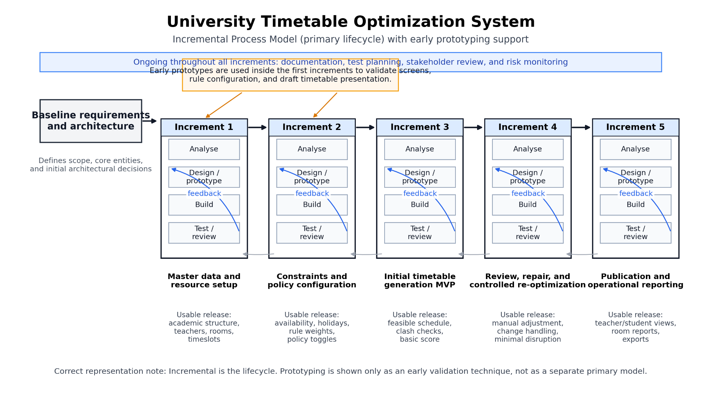
Figure 1. Incremental process model for the University Timetable Optimization System.
5.1 Diagram Description
The diagram shows one baseline requirements and architecture stage followed by five increments. Each increment contains analysis, design/prototyping, build, and test/review activities. This representation is intentionally incremental rather than purely linear. It shows that the system grows through controlled slices: master data first, rule configuration second, a feasible generation MVP third, repair capability fourth, and publication/reporting fifth. The note at the bottom clarifies the modelling decision: prototyping supports early validation, but it is not treated as the primary lifecycle.
6. Justification for the Selected Model
6.1 Requirement discovery happens after draft schedules are seen
Universities often believe their timetable rules are already known, but many constraints appear only when users inspect draft schedules. Typical examples include room proximity for back-to-back classes, a teacher’s preferred day pattern, or the need to change one class without disturbing all others. Incremental development allows these discoveries to shape later increments without forcing a restart.
6.2 The system is modular enough for staged delivery
The project can be partitioned into coherent slices: academic structure and resources, constraints and preferences, timetable generation, timetable review, change handling, and publication. This is exactly the kind of architecture that suits incremental delivery because each slice has a meaningful output and can be validated before the next slice is added.
6.3 The project needs learning, but not the full overhead of Spiral
The timetable logic is uncertain enough to require experimentation and user feedback, but the project is still small enough that a Spiral lifecycle would introduce unnecessary management overhead. Incremental development is therefore the practical middle ground between a rigid one-pass model and a heavily risk-driven process.
6.4 Controlled repair is part of the product, not an afterthought
A timetable system is not finished once the first draft is generated. Teachers may request changes, rooms may become unavailable, and blocked days may need to be inserted. A good lifecycle must therefore accommodate controlled repair and re-optimization as normal project growth. Incremental development fits this behaviour much better than Waterfall, which is strongest when most of the design can remain fixed after early stages.
6.5 Coursework still requires documentation and traceability
Each increment can produce updated artefacts such as requirement notes, UI decisions, test results, and design refinements. This keeps the project academically traceable without forcing the team into a purely documentation-first lifecycle.
7. Why the Alternatives Were Not Selected
Waterfall was not selected because it assumes that most important requirements can be fixed early and then implemented with limited backtracking. That assumption is weak for this project. Timetable systems commonly reveal missing rules only after prototype screens or generated schedules are reviewed, and late changes to policy weights, room priorities, or repair behaviour would become expensive in a strict linear flow.
Spiral was not selected as the main lifecycle because the project does not justify that level of continuous risk-management overhead. Agile/XP practices remain useful within increments, especially for short review cycles, but they are better treated as implementation practices rather than as the single formal lifecycle label for this report.
8. Proposed Increment Plan
Increment | Main focus | Usable result | Why it comes here
1 | Academic calendar, courses, sections, teachers, rooms, timeslots | Validated master data foundation | Generation cannot start until the scheduling facts exist.
2 | Constraints, preferences, holidays, policy toggles | Configurable rule base | The generation engine must work from explicit rules rather than hidden assumptions.
3 | Initial timetable generation and clash reporting | First feasible timetable draft | A draft schedule is needed before quality and hidden constraints can be discussed meaningfully.
4 | Review, repair, and controlled re-optimization | Change-aware timetable management | Real deployments require late adjustments and minimal disruption after requests.
5 | Publication, views, exports, and resource reports | Operationally usable release | End users consume the timetable only after the core drafting and repair functions are stable.
9. Conclusion
The final selection is the Incremental Process Model, with early prototyping used only as a supporting validation technique. This decision is justified by the nature of the project: timetable rules evolve after draft schedules are reviewed, the system architecture can be partitioned into clear slices, and the project needs more flexibility than Waterfall without the full process overhead of Spiral. Therefore, Incremental is the most defensible and academically appropriate primary lifecycle for the University Timetable Optimization and Management System.
References
- Sommerville, I. (2016). Software Engineering (10th ed.). Pearson.
- Pressman, R. S., & Maxim, B. R. (2019). Software Engineering: A Practitioner’s Approach (9th ed.). McGraw-Hill.
- Larman, C. (2004). Applying UML and Patterns (3rd ed.). Prentice Hall.

